Child and Parent Interview: Age 3-6

Daphne O. Pack
Department of Home and Family, Brigham Young University—Idaho
CHILD 310: Early & Middle Child Development
Brother Trevor Rowe
November 14, 2025

Introduction
Kayana and her family used to live in my ward growing up and she was my young women’s leader for a time. Several years ago, they moved to Rexburg, and I had not seen them since. Now they have a seven-year-old daughter and a four-year-old son. Their son Ford is active and curious and loves his family. I spent about an hour with Kayana and Ford at their house one morning and got to see a snippet of life with and as a four-year-old. In this paper, I will discuss the observation and interview and provide practical applications and recommendations from what I learned.
Interview Questions
Listed below are some of the questions I asked during this interview.
- Can you tell me about your friends?
- How well does Ford interact with others?
- Can you tell me about what kinds of games you like to play?
- Is Ford good at sharing?
- Why is it good to share with your sister?
- Do you like to play with yourself more or with other people? What is different?
- How is Ford with following rules and limits?
- Can you tell me more about that rule?
- What is your favorite thing you have?
- What do you love about your family?
- Do you like to make stuff?
- Can you show/describe it to me?
Summary of the Interview
With my isolated time with Kayana and Ford, I took a casual approach to preserve the normal atmosphere of Ford’s daily life. Although he had never met me, he warmed up quickly when I asked about his pet dog. With a little prompting from his mom, he told me the dog’s name was Moose, and he was his best friend. Upon mentioning this, I asked him about his friends from school and church. He was uninterested in answering and instead wanted his mom to read him a book, now that he was comfortable with my presence.
Kayana scooped him up into her lap and started reading from the Halloween themed picture book Ford picked out. She paused frequently and asked him what he saw and what happened next in the story. I asked what he likes about reading books and he said he likes when his mom does silly voices and when he guesses what is going to happen next.
Then he gave me a little house tour and showed me his bedroom, playroom, and backyard. He showed me all his favorite toys (he could not pick a favorite), but after asking about playing, he said he prefers playing with friends than alone. I asked why and he said, “I get sad when I’m alone.” I asked Kayana how Ford usually plays with his friends and she told me he plays really well with other children and loves being social at church and preschool. I asked how he likes to play with his friends and he told me all about playing Star Wars with his cousin and pretending to be puppies and other animals outside with his friends.
Then Ford took me outside and showed me his motorized car that he likes to drive around the yard. Kayana told me the car is one of her kids’ favorite toys. I asked if Ford was good at sharing and she said he loves to share, especially with his sister. He’s very caring and will normally share toys with his friends as well. Then I asked Ford why it was good to share and he said it was nice to do and everyone would cry if no one shared.
After playing outside, I asked Ford if he liked to make art. He said he liked to color and use stamps, so his mom brought out the art supplies. He started stamping colorful ink on the paper in the shapes of animals. I asked what he was making and he said, “A zoo!” I asked what he liked about his family and he said, “They’re nice!” He said he loves his sister and his mom and dad. I asked if they had any rules at home. He said yes and with Kayana’s prompting he thought of a couple. “At dinner we eat, not play,” “We only play in the backyard,” and “We always follow Jesus!” Kayana said she tries to set healthy limits for her kids surrounding outside time, screen time, and family time to keep them safe.
The visit ended with Ford cooking macaroni and cheese with Kayana’s guidance. She said he loves to help cook and she loves to support him (even when he does it slowly and makes messes).
Reflection and Application
Upon reflection, this interview was the perfect look into the daily life of a four-year-old. Ford perfectly aligned with where he should be developmentally. I willingly participated but was easily distracted. He has a secure relationship with his family and loves to play in various ways. I can apply what I learned in my own family and potential future employments by visualizing my experience with Ford and applying it to other children. Kayana did a great job scaffolding Ford’s learning experiences by providing various tools, letting him take appropriate risks, and building activities off of his interests and choices.
Research Based Recommendations
Based on what I observed during the interview and the learning I have done, I would make a few recommendations to Ford’s family. One suggestion would be to provide more play time with other children. Ford plays with kids at preschool but rarely has play dates outside of school. According to Berk (2023), “peers provide young children with learning experiences they can get in no other way. Because peers interact on an equal footing, they must keep a conversation going, cooperate, and set goals in play.” In a study on the importance of peer play for young children, Scott and Cogburn (2023) state, “Between the ages of 3 to 6 years, play provides the opportunity for cognitive skills to develop and increases the child’s mental capacities.” While time at home with his mom is good, more time with his peers will be beneficial to Ford in all areas of his development.

Appendix
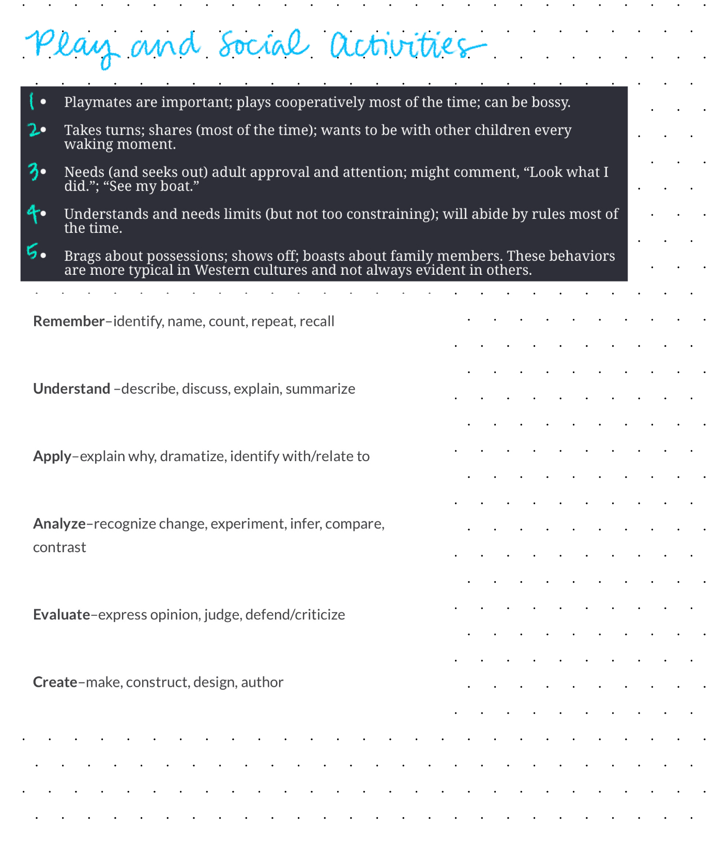

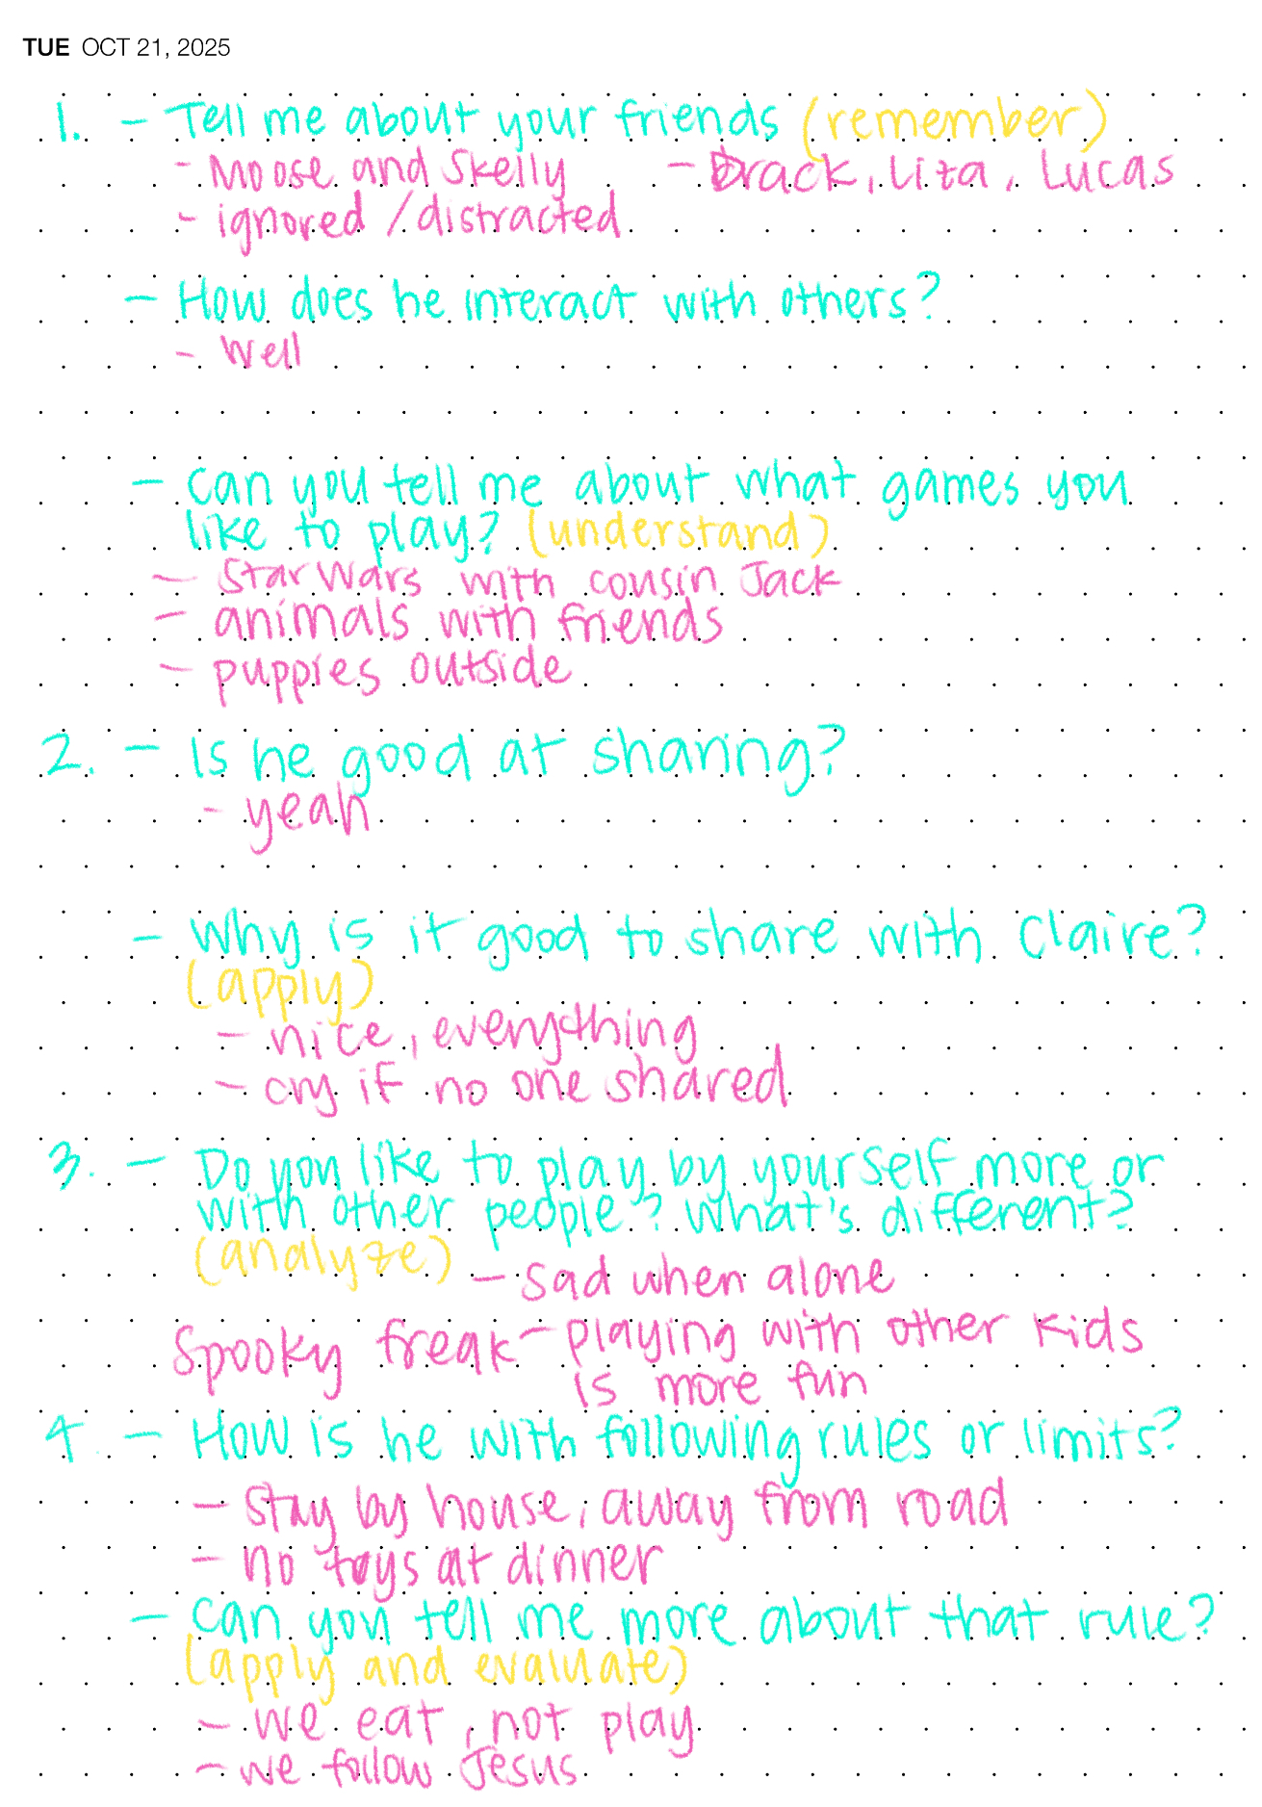
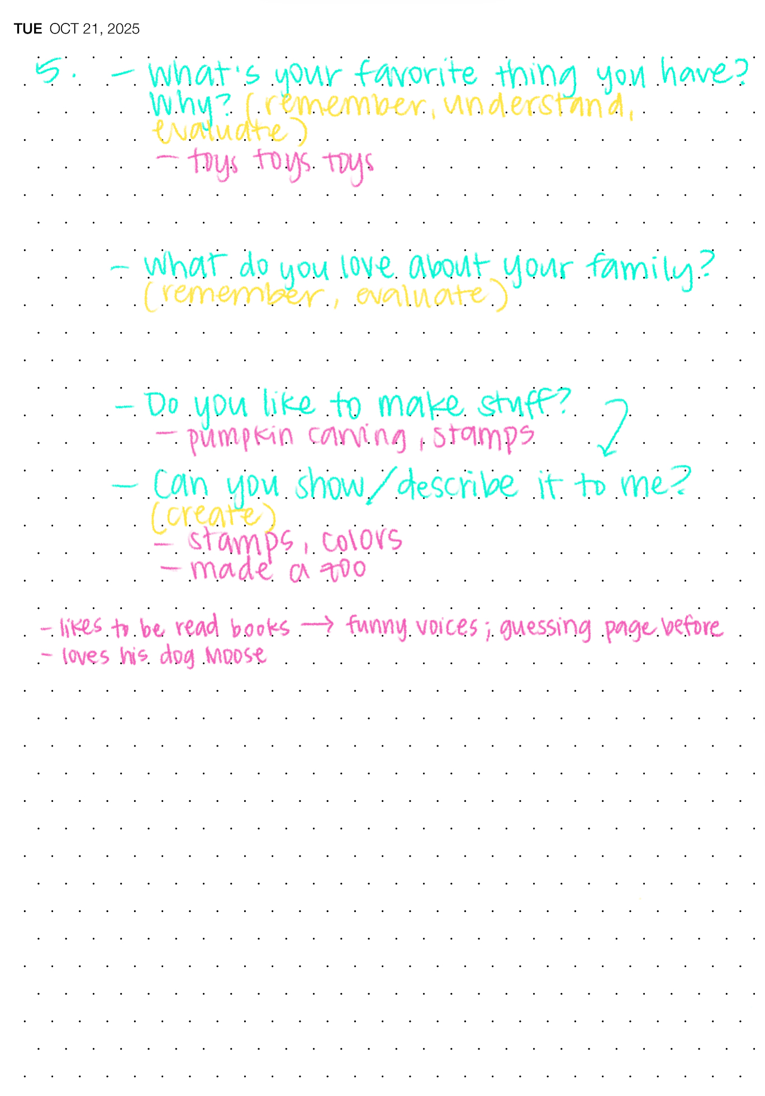
References
Berk, L. E. (2023). Infants, children, & adolescents. 9, 363.
Marotz, L. R. (2023). Developmental profiles: Pre-birth through adolescence. 9, 149-156.
Scott, H.K., & Cogburn, M. (2023). Peer play. StatPearls.

